M.B. ARTS & COMMERCE COLLEGE

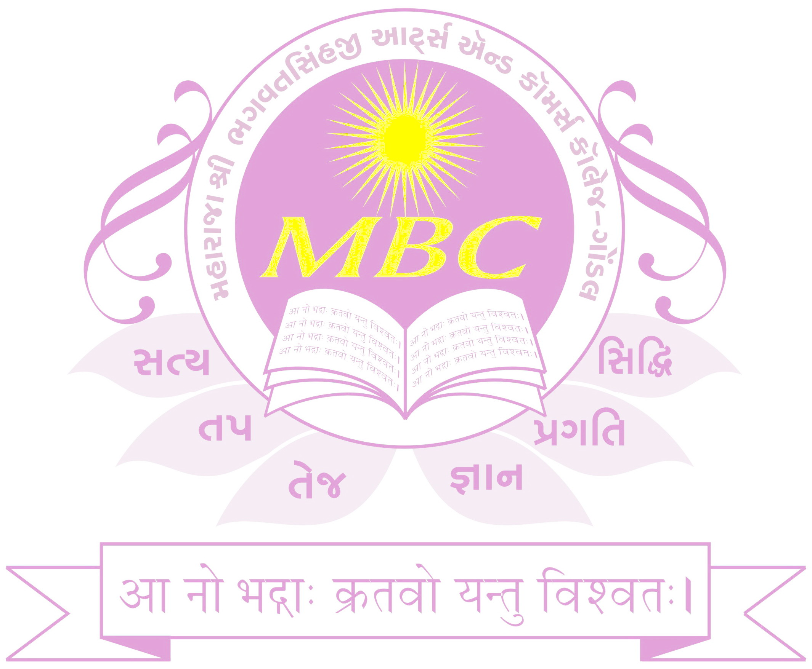
Swami Vivekanand Road, Gondal - 360311

Project Certificate

This is to certify that _ GARANIYA HARDIK B. (003203213982), GARANIYA KAPIL V.(003203213983) & GARANIYA CHINTAN A. (003203213981) Students of B.C.A. Semester - VI for the Academic Year 2023-2024 And Has Undergone the Project The Project Work On APMC WEBSITE Part Of B.C.A. Sem - VI Course.
They Has Successfully Completed Their Project with ASP.NET and used SQL as Database.
We Wishes them Best of Luck for their Brighter Future.

Date : - 25TH FEBRUARY 2024

(V.M. Isotiya) (Dr. S.J.Jhala)

Head (Computer Sci. Dept.) Principal
M.B. Arts & Commerce College, M.B. Arts & Commerce College,
Gondal Gondal

